CSIT314 Software Development Methodologies - Group Project

Sprint 2 - US15: View company profile
Interior Design Platform - Interior Designer
All diagrams were drawn in draw.io. Open "US15 View company profile.drawio" in this folder to edit them - each diagram is its own page in that file. The exported images are in the "diagrams" folder.

Assumptions
- The system is the Interior Design Platform from the project specification. Sprint 2 covers the Interior Designer's log in, company profile and log out stories (US13 - US19) and the Platform Manager's log in, log out and IDP category stories (US39 - US45).
- We follow B-C-E: the actor only talks to the boundary (page), the boundary only talks to the controller, and the controller works with the entity classes. There is one controller per use case.
- The boundary checks all the input (required fields, lengths, formats, e.g. not suspending your own profile) and trims spaces, then passes an entity object on. The controller just calls the entity and returns the result. The entity checks for duplicates and the database state (e.g. name already used, only Active rows are changed), then saves. US15 has no typed input: the page takes the designer from the session, ViewCompanyProfileController only calls CompanyProfile.getCompanyProfile(), and the entity only returns an Active profile.
- Viewing is read-only. It only reads the designer's row in the company_profile table (from US14) and never changes it. No new table is needed.
- A designer can only use their own company profile. The owner always comes from the logged-in session, so a designerId or companyId put in the URL or the form is ignored.
- The page only shows the business details customers would see: company name, description, services, email, phone and address. Internal IDs, the created date and the designer's own account details are not shown.
- Optional fields that are empty show "Not provided".
- The company details are in a reusable template (companyProfileDetails.html) so the later customer pages can show the same card.
- If the designer has no Active company profile (never created, or deleted with US17), the system shows "You have not created a company profile yet" (HTTP 404) with a link to create one (UC14).
- Logged in as an interior designer (UC13) is the precondition. designerLoginRequired in app.py only sends someone with no session to /designer/login; the use case doesn't check the designer again.

1. User story
Story ID | US15
User story | As an interior designer, I want to view my company profile so that I can check what customers see.
Actor | Interior Designer
Priority | High
Story points (estimate) | 2
Acceptance criteria | 1. Given I have a company profile, the designer dashboard shows a "View company profile" button.  2. Given I click it, then I see my company name, description, services, email, phone and address.  3. Given an optional field is empty, then it shows "Not provided".  4. Given I have no company profile, then I see "You have not created a company profile yet" and a "Create company profile" button.  5. The page is read-only. "Back to dashboard" goes back to the dashboard and nothing is changed.  6. I can only see my own company profile, never another designer's.
Tasks | T15.1 Write the use case description and draw the use case diagram  T15.2 Draw the B-C-E class diagram and the sequence diagram  T15.3 Draw the wireframes for the view button, the company details, no profile and empty optional fields  T15.4 Write the unit tests first (TDD) for ViewCompanyProfileController and the view page  T15.5 Code ViewCompanyProfileController.viewCompanyProfile(designerId): one call to CompanyProfile.getCompanyProfile()  T15.6 Code ViewCompanyProfilePage, the reusable company details template and the not-found page  T15.7 Add the "View company profile" button to the designer dashboard  T15.8 Run the test cases, fix bugs and push to the repo so the CI pipeline runs the unit tests

2. Use case diagram
The user story becomes one use case, UC15 View company profile. The Interior Designer is the only actor.
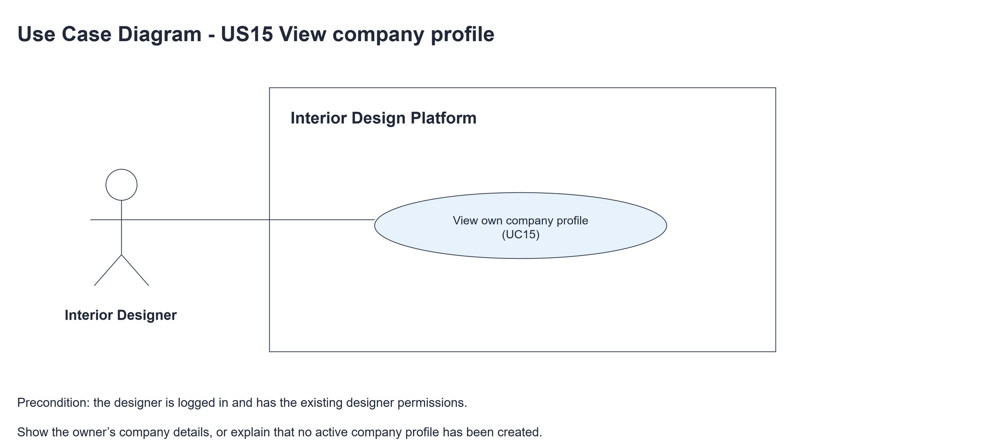
Figure 1: Use case diagram for US15 View company profile

3. Use case description
Use case | UC15 View company profile
Actor | Interior Designer
Brief description | The Interior Designer views their own company profile to check what customers will see.
User story | US15: As an interior designer, I want to view my company profile so that I can check what customers see.
Preconditions | The Interior Designer is logged in (UC13). designerLoginRequired in app.py only sends someone with no session to /designer/login.
Trigger | The Interior Designer clicks "View company profile" on the designer dashboard.
Basic flow | 1. The Interior Designer clicks "View company profile".  2. The system finds the Active company profile owned by the logged-in designer.  3. The system shows the company name, description, services and contact details.  4. The Interior Designer clicks "Back to dashboard" when finished.
Alternative flows | 2a. The designer has no Active company profile (never created, or deleted): the system shows "You have not created a company profile yet" and a "Create company profile" button (HTTP 404). The use case ends.  3a. An optional field is empty: the system shows "Not provided" for it.
Postconditions | The company profile is shown. Nothing in the database is changed.

4. Wireframes
The wireframes were drawn in draw.io. They are low-fidelity: they show the layout and the flow, not the final colours. The orange numbers match the notes under each screen.

4a - View button
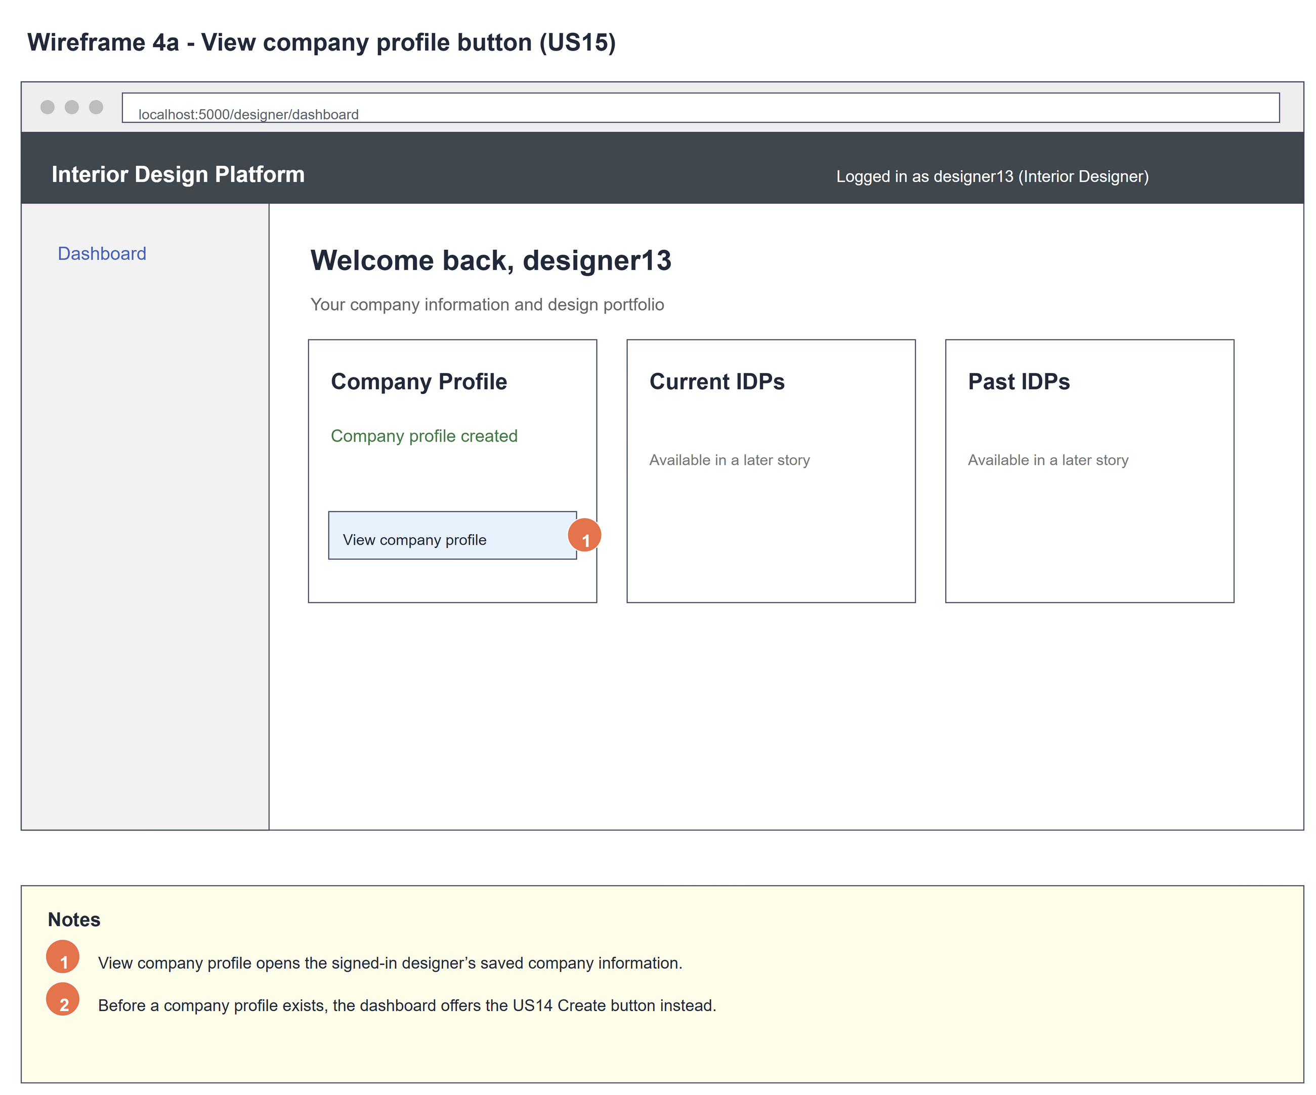
Figure 2: Wireframe 4a - View button (US15)

4b - Company details
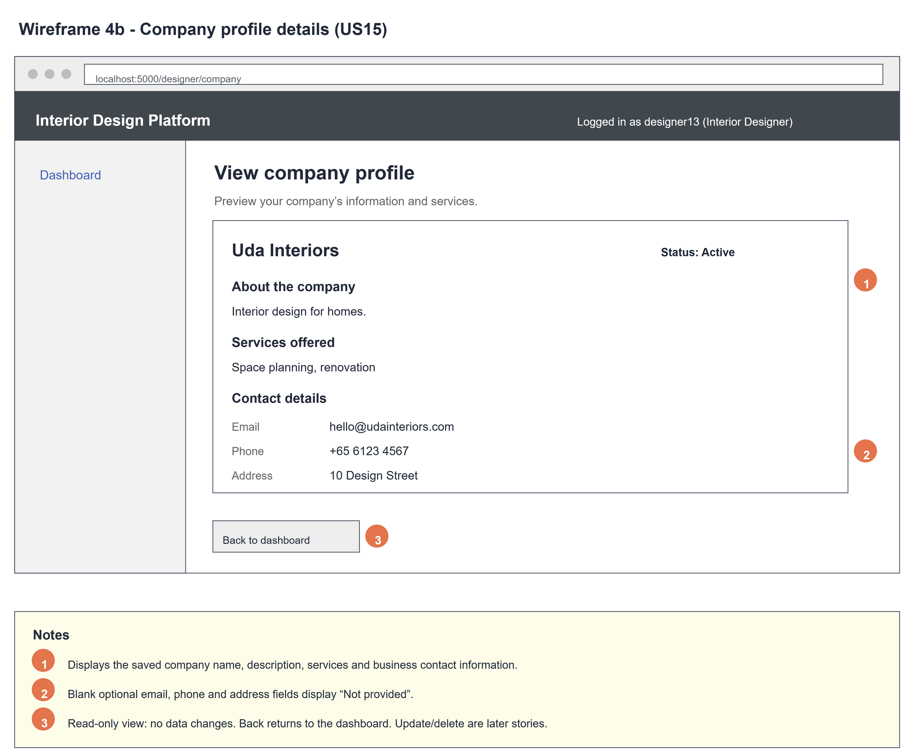
Figure 3: Wireframe 4b - Company details (US15)

4c - No company profile
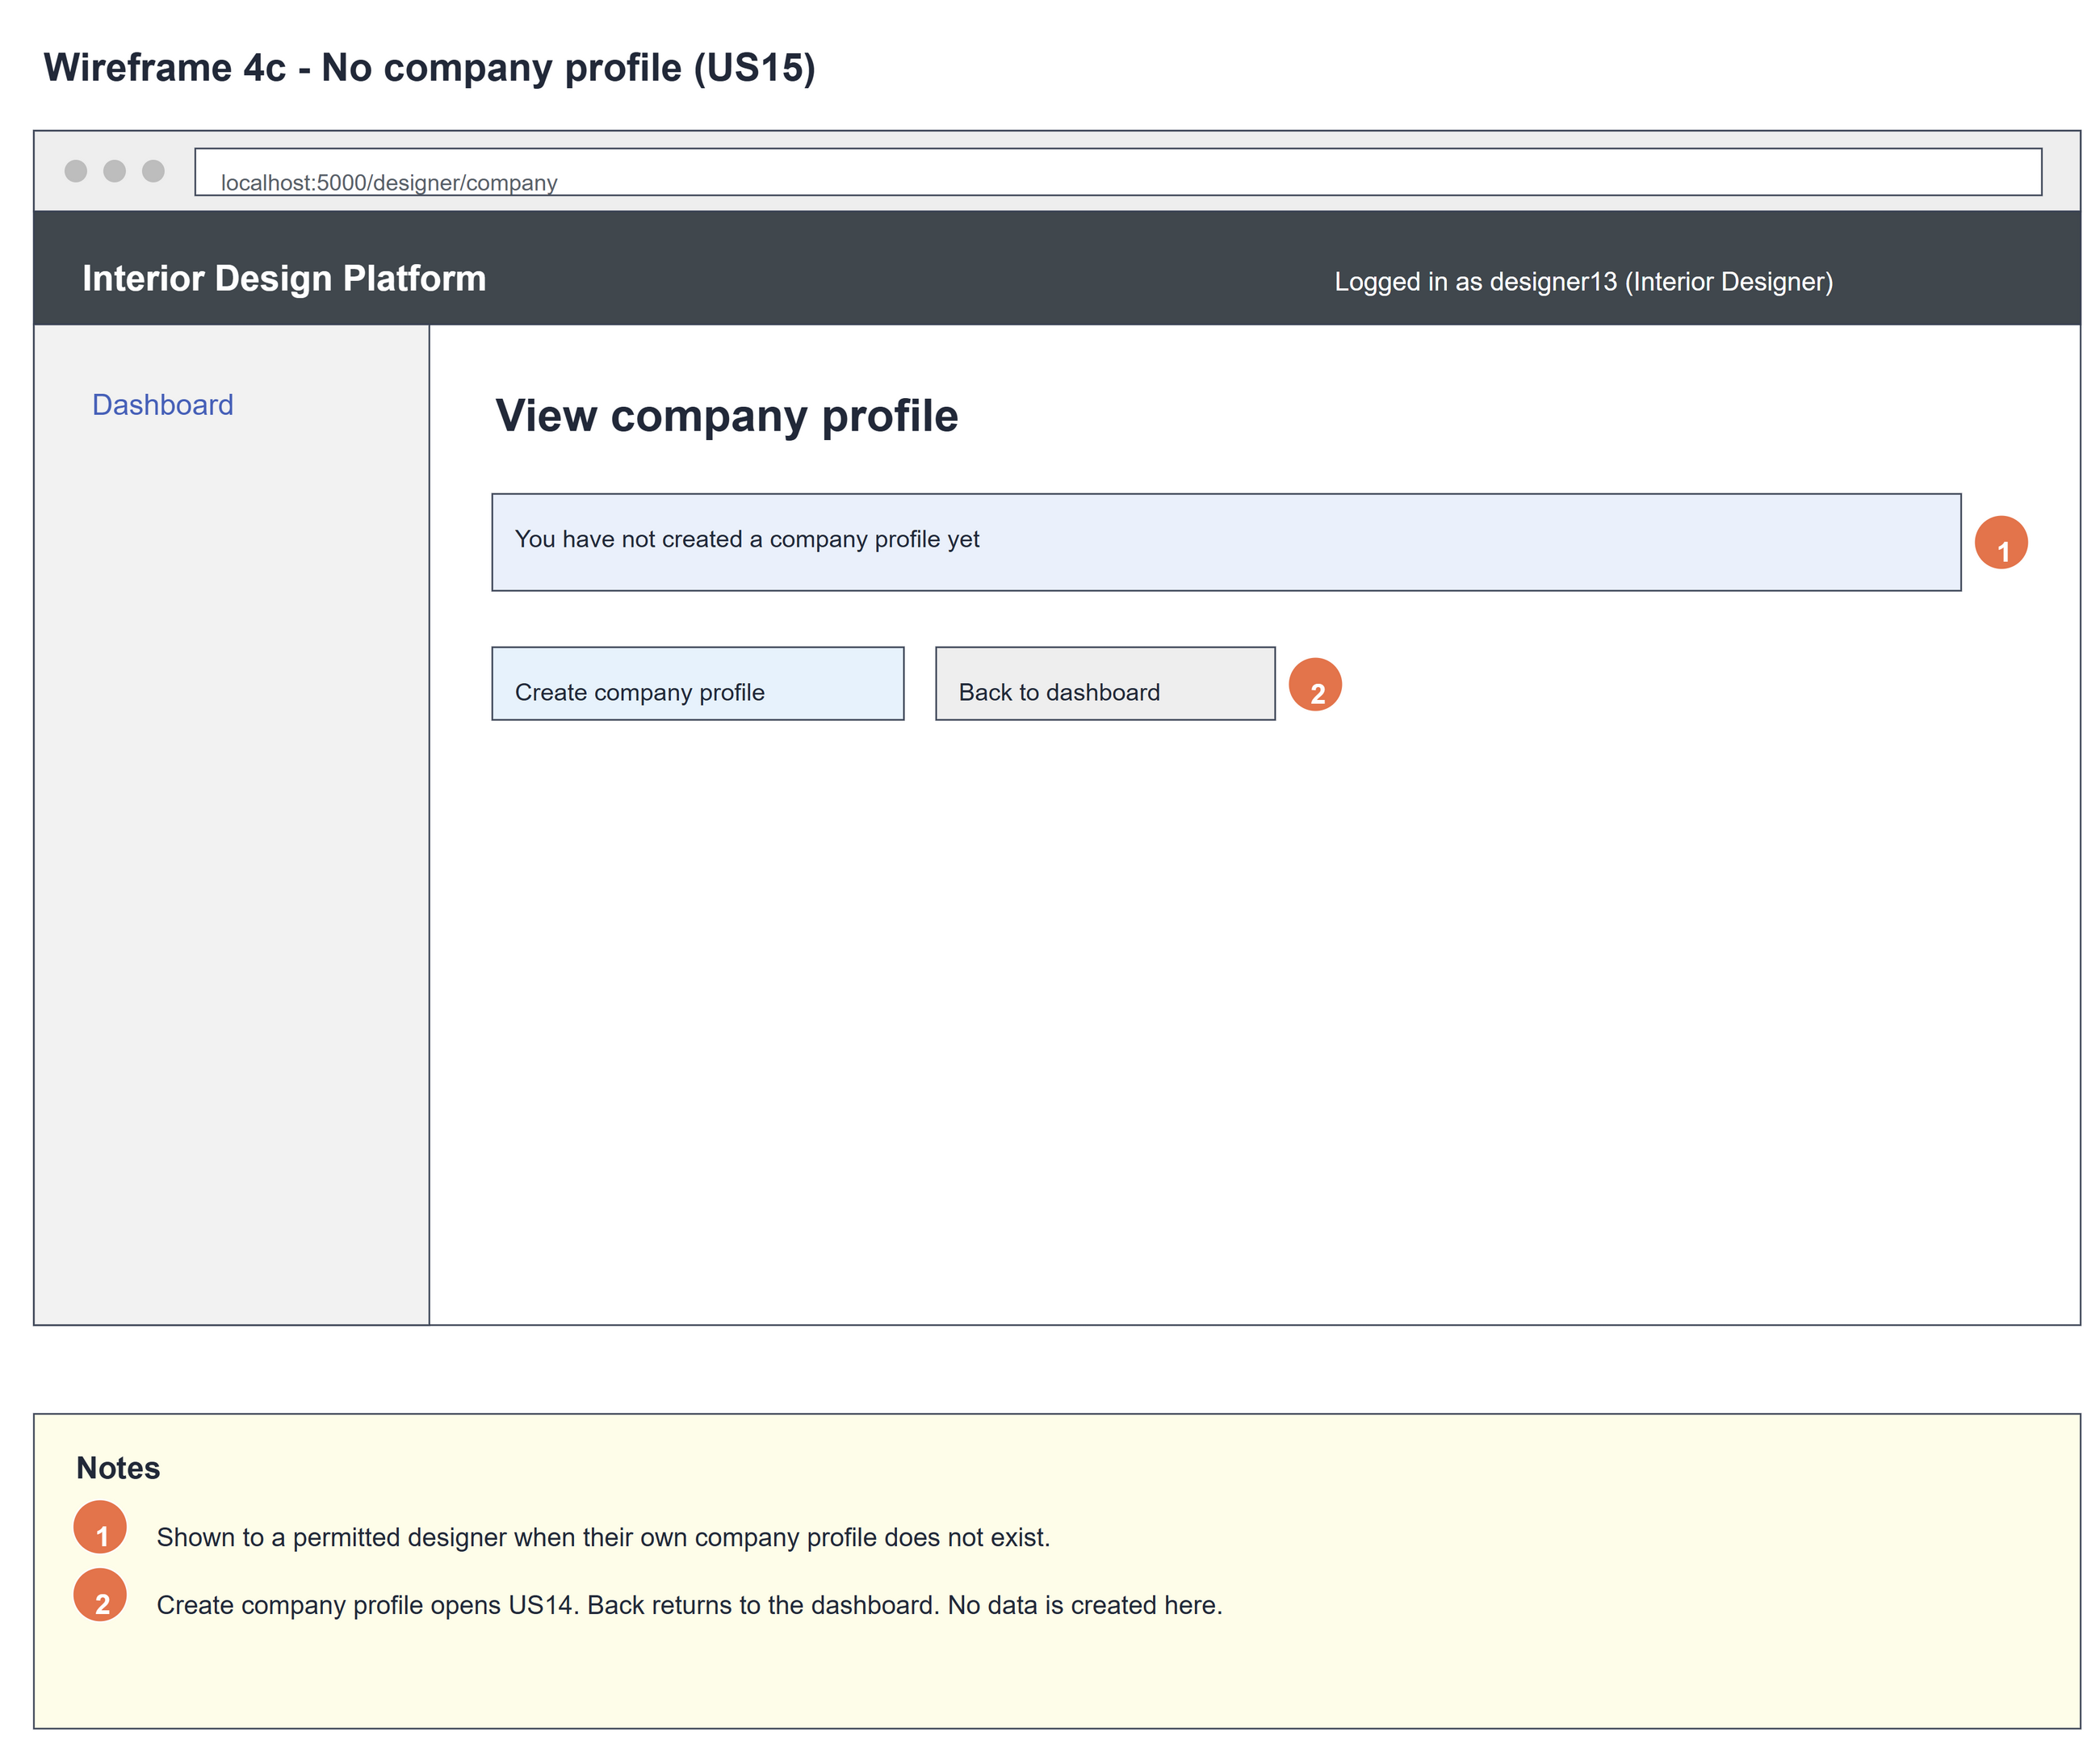
Figure 4: Wireframe 4c - No company profile (US15)

4d - Optional fields empty
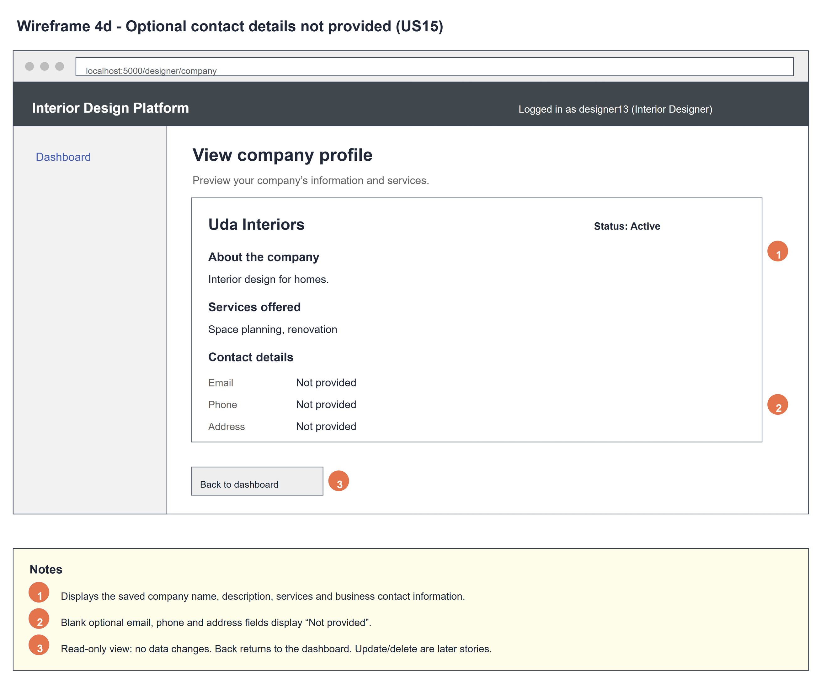
Figure 5: Wireframe 4d - Optional fields empty (US15)

5. B-C-E class diagram
The solid line means the boundary calls the controller. The dashed line means the controller uses the entity class. Only the operations needed for this use case are shown.
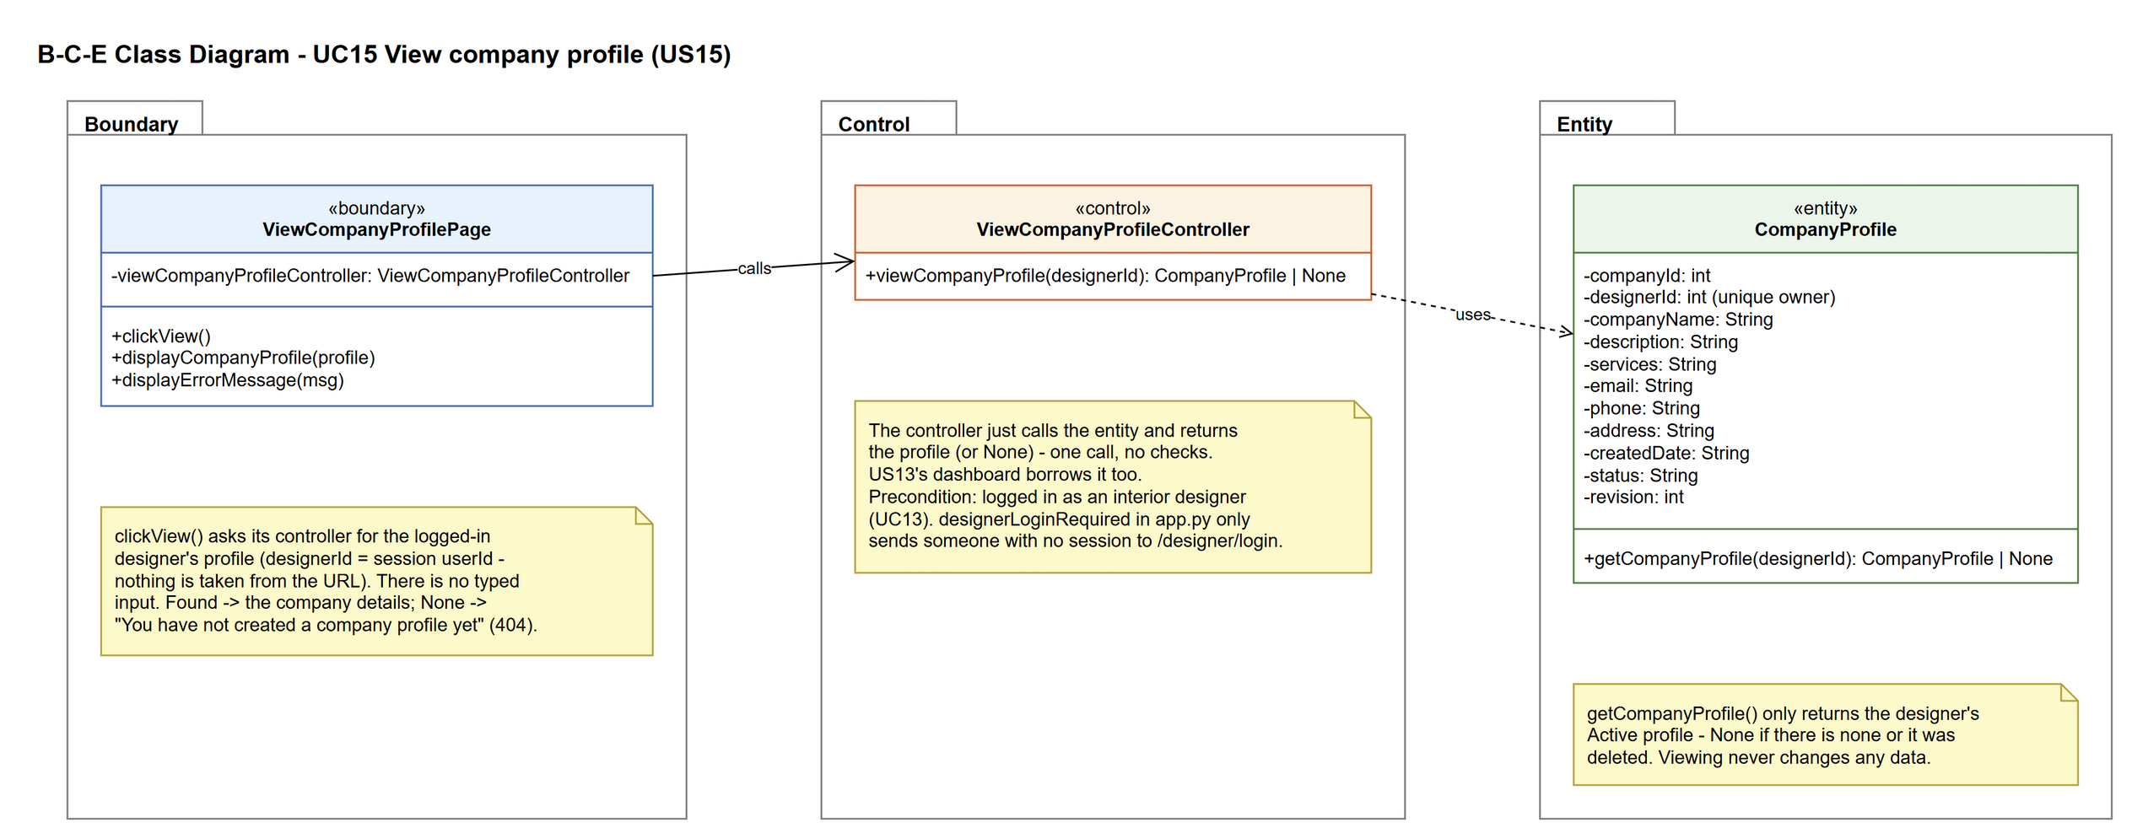
Figure 6: B-C-E class diagram for US15 View company profile
Layer | Class | What it does
Boundary | ViewCompanyProfilePage | The company profile page. clickView() asks the controller for the profile using the session userId (nothing is taken from the URL), then shows it (displayCompanyProfile) or the not-found page (displayErrorMessage, HTTP 404).
Control | ViewCompanyProfileController | Controller for UC15. viewCompanyProfile(designerId) just calls CompanyProfile.getCompanyProfile() and returns the profile or None. US13's dashboard borrows it to decide whether to show "View company profile".
Entity | CompanyProfile | The company profile from US14. getCompanyProfile() returns the designer's Active profile, or None.

6. Sequence diagram
The sequence diagram follows UC15. The page takes the designer from the session and asks its controller for the profile (step 1). The controller makes one call to CompanyProfile.getCompanyProfile(), which only returns the designer's Active profile (step 2). The alt shows the company details (step 3) or the "no company profile" page (alternative flow 2a, HTTP 404).
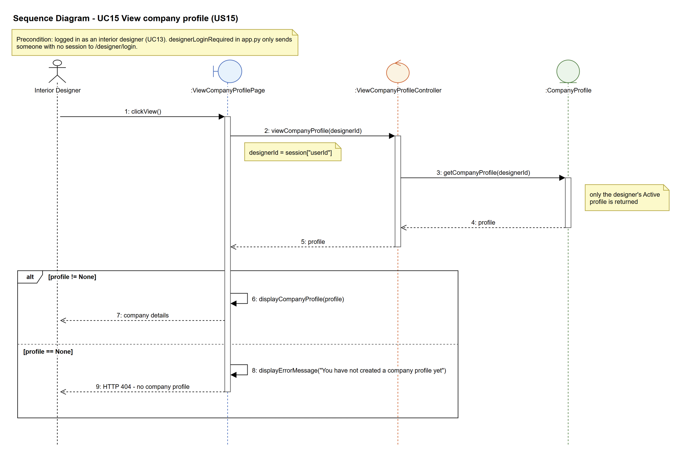
Figure 7: Sequence diagram for UC15 View company profile

7. Test cases
Test data used below (same as database/seedData.py and the test files): user profiles User Admin (id 1), Interior Designer (id 2), Customer (id 3) and Platform Manager (id 4), all Active. User accounts admin01 / Admin@123 (User Admin) and cust001 / Cust@123 (Customer). The designer account designer13 / Design@123 (Tengku Uda Designer, Interior Designer profile) is made first with UC8. Company data: Uda Interiors, "Interior design for homes.", "Space planning, renovation", hello@udainteriors.com, +65 6123 4567, 10 Design Street.

7a. System test cases (black box)
Equivalence partitioning and boundary value analysis were used to pick the test data. Fill in "Actual result" and "Pass/Fail" after running each test.
Test ID | Scenario | Prerequisites | Test steps | Test data | Expected result | Actual result | Pass / Fail
TC15.1 | View the company profile | Logged in as designer13. TC14.1 done. | 1. Click "View company profile" on the dashboard | - | The page shows Uda Interiors, the description, services, email, phone and address.
TC15.2 | Optional fields empty | Logged in as designer13. Profile saved with no email, phone or address. | 1. Click "View company profile" | - | Email, Phone and Address each show "Not provided".
TC15.3 | No company profile | Logged in as designer13. No company profile. | 1. Open /designer/company | - | "You have not created a company profile yet" and a "Create company profile" button.
TC15.4 | Can't view another designer's profile | designer15 has a profile. Logged in as designer13. | 1. Open /designer/company?designerId=<designer15's id> | designerId of designer15 | Still shows designer13's own profile (Uda Interiors).
TC15.5 | Back to dashboard | Viewing the company profile. | 1. Click "Back to dashboard" | - | The dashboard is shown. Nothing has changed.
TC15.6 | Not logged in | Not logged in. | 1. Open /designer/company | - | Sent to the designer login page.
TC15.7 | Deleted profile | designer13's profile was deleted (UC17). | 1. Open /designer/company | - | "You have not created a company profile yet" (HTTP 404). The deleted details are not shown.

7b. Unit test cases (for TDD)
These are written before the code (test-driven development) and run automatically in the CI pipeline. They cover normal inputs, abnormal inputs and boundary values. Each one matches a test function in tests/test_us15_viewCompanyProfile.py (UT15.1 is test_ut15_1_...). "Pass" is from the pytest run on 9 November 2026.
Test ID | Class and method | Input / setup | Expected output | Type | Pass / Fail
UT15.1 | ViewCompanyProfileController.viewCompanyProfile() | designer13's userId (has a profile) | Returns the profile, companyName "Uda Interiors" | Normal | Pass
UT15.2 | ViewCompanyProfileController.viewCompanyProfile() | designer13 with no profile | Returns None | Abnormal | Pass
UT15.3 | ViewCompanyProfileController.viewCompanyProfile() | userId 9999 | Returns None | Abnormal | Pass
UT15.7 | ViewCompanyProfileController.viewCompanyProfile() | designer13 (has a profile) | The company_profile table is unchanged | Normal | Pass
UT15.8 | CompanyProfile.getCompanyProfile() | designer13's userId | All fields match what was saved | Normal | Pass
UT15.9 | CompanyProfile.getCompanyProfile() | designer15 (no profile) | Returns None, not designer13's profile | Abnormal | Pass
UT15.10 | ViewCompanyProfilePage.clickView() | GET /designer/company as designer13 | All six company values shown | Normal | Pass
UT15.11 | designerLoginRequired (app.py) | GET /designer/company, not logged in | Redirects to /designer/login | Abnormal | Pass
UT15.13 | ViewCompanyProfilePage.displayErrorMessage() | designer13 with no profile | HTTP 404, "You have not created a company profile yet" and a create link | Abnormal | Pass
UT15.14 | ViewCompanyProfilePage.displayCompanyProfile() | email, phone and address empty | "Not provided" shown 3 times | Boundary | Pass
UT15.15 | ViewCompanyProfilePage.clickView() | URL has designerId and companyId of another designer | Shows only Uda Interiors | Abnormal | Pass
UT15.16 | ViewCompanyProfilePage.clickView() | designer15 (no profile) adds ?designerId=4 | HTTP 404. Uda Interiors not shown | Abnormal | Pass
UT15.17 | ViewCompanyProfilePage.displayCompanyProfile() | description = "<script>alert(1)</script>" | Shown escaped, not run | Abnormal | Pass
UT15.18 | ViewCompanyProfilePage.displayCompanyProfile() | GET /designer/company | No password, full name, account email or password field shown | Normal | Pass
UT15.19 | ViewCompanyProfilePage.clickView() | Open the page twice | The company_profile table is unchanged | Normal | Pass
UT15.20 | ViewCompanyProfilePage (read-only) | GET, then POST /designer/company | No form fields in the company content; POST gives HTTP 405 | Abnormal | Pass
UT15.21 | Designer dashboard (UC13) | designer13 with a profile | Shows the "View company profile" link | Normal | Pass
UT15.22 | Designer dashboard (UC13) | designer13 with no profile | No view link; shows the create link | Normal | Pass
UT15.24 | Create then view | Create the profile, then open /designer/company | Success message, then the saved details | Normal | Pass
UT15.25 | ViewCompanyProfilePage.clickView() | designer13's profile deleted with suspendCompanyProfile(designerId, companyId, expectedRevision) (test_ut15_suspendedProfile_isUnavailable) | HTTP 404. Uda Interiors is not shown | Abnormal | Pass

